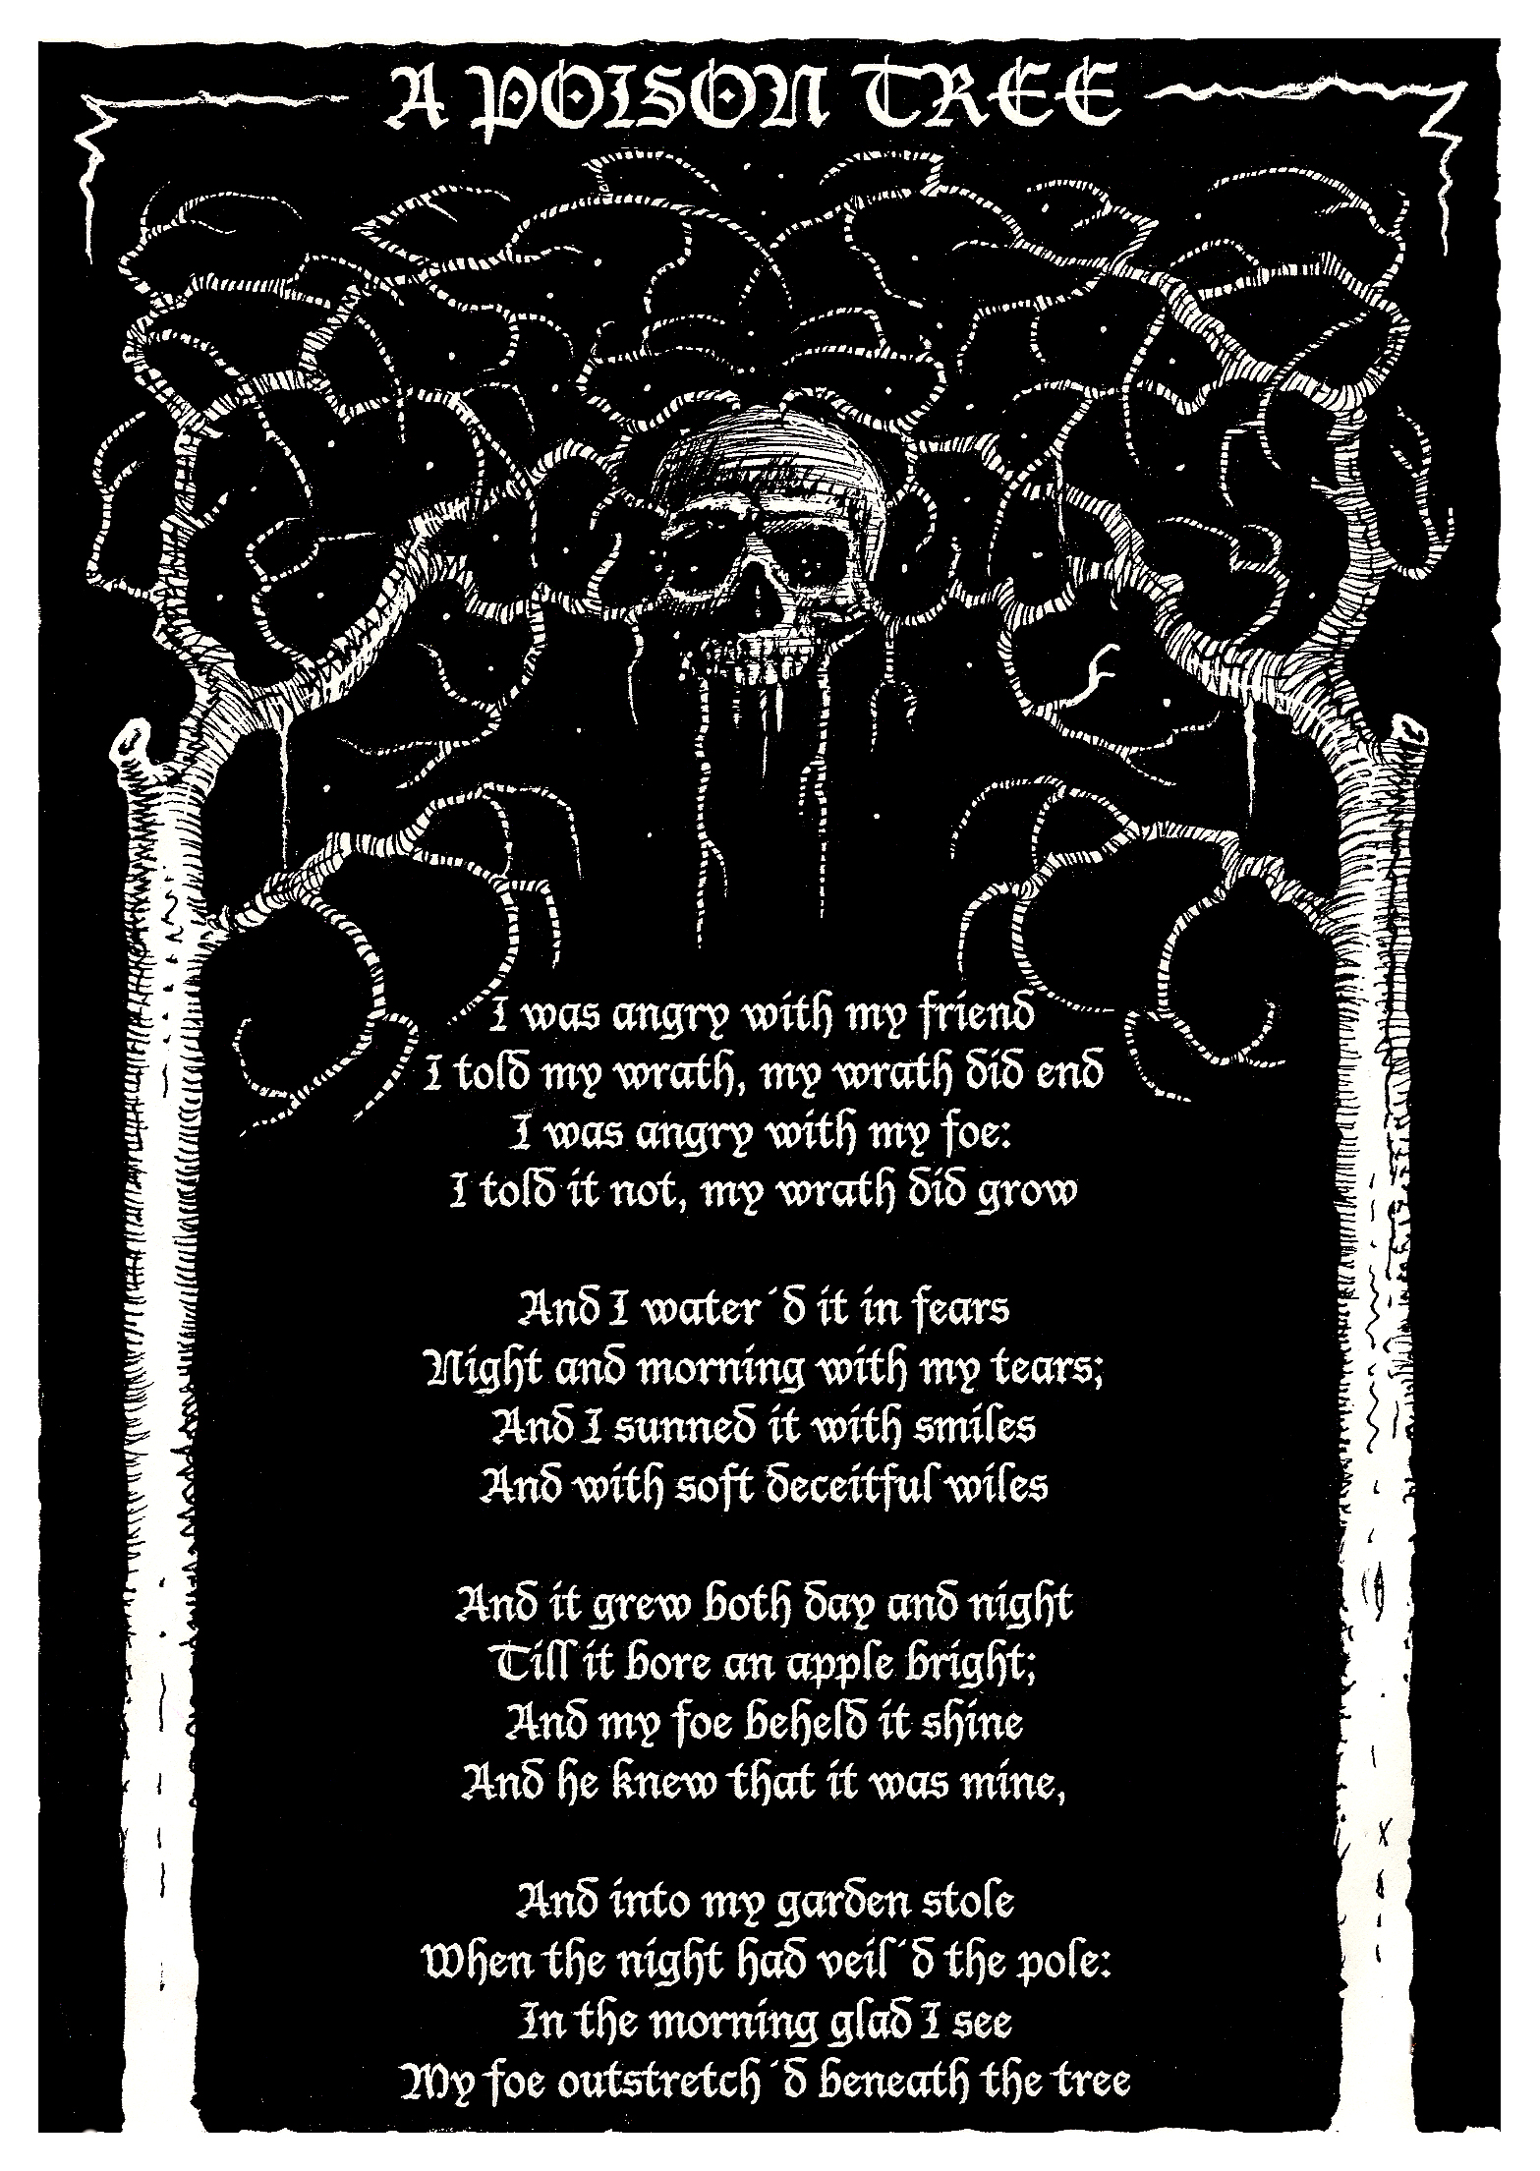 A Poison Tree
by William Blake

I was angry with my friend;
I told my wrath, my wrath did end.
I was angry with my foe:
I told it not, my wrath did grow.
5 And I waterd it in fears,
Night & morning with my tears:
And I sunned it with smiles,
And with soft deceitful wiles.
And it grew both day and night,
10 Till it bore an apple bright.
And my foe beheld it shine,
And he knew that it was mine.
And into my garden stole.
When the night had veiled the pole;
15 In the morning glad I see,
My foe outstretchd beneath the tree.

Blake uses a literary device called antithesis—a device in which two contrasting or opposite ideas balance one another, often due to similar grammatical structures.
An example of antithesis can be found in Martin Luther King, Jr.’s famous “I Have a Dream” speech, in which he says that he dreams of a nation where his children “will not be judged by the color of their skin but by the content of their character.”

- Where else can you find opposites in the poem?____________________________________________________________ ______________________________________________________________________________________________________________________________________________________________________________________________________________________________________________________________________________________________________________________________________________________

- In the first stanza, what do you think the speaker means by “I told my wrath”? How might that prevent anger from growing? ________________________________________________________________________________ ______________________________________________________________________________________________________________________________________________________________________________________________________________________________________________________________________________________________________________________________________________________

- In the second stanza, what does “it” refer to?_______________________________________________________________ ____________________________________________________________________________________________________________________________________________________________________________________________________________________________________

- What do you associate with the word “apple”? What do you think it symbolizes in the third stanza? ________________________________________________________________________________________________________________________________________________________________________________________________________________________________________________________________________________________________________________________________________________________________________________________________________________________________________________________________________

- Was the last line surprising? Why or why not?______________________________________________________________ ______________________________________________________________________________________________________________________________________________________________________________________________________________________________________________________________________________________________________________________________________________________

- Do you think the speaker would have preferred that his anger with his foe had ended? What evidence can you find to back up your claim? ______________________________________________________________ ________________________________________________________________________________________________________________________________________________________________________________________________________________________________________________________________________________________________________________________________________________________________________________________________________________________________________________________________________

- Consider the title. What is the “poison” of the tree referring to?__________________________________________ ______________________________________________________________________________________________________________________________________________________________________________________________________________________________________________________________________________________________________________________________________________________

Artists and writers often reference literary, visual, and historical works in their own art and writings. This device is called allusion.

- Identify allusions to Adam and Eve in “A Poison Tree.”
- What opposing forces are reflected in the story of Adam and Eve?
- Why do you think Blake references this biblical story in his poem?
__________________________________________________________________________________________________________________________________________________________________________________________________________________________________________________________________________________________________________________________________________________________________________________________________________________________________________________________________________________________________________________________________________________________________________________________

“A Poison Tree” is part of an illustrated collection of poems called Songs of Experience, which follows a series called Songs of Innocence. The poems in Songs of Innocence explore the innocent state of childhood, whereas those in Songs of Experience explore how oppressive forces and the fears and flaws of human nature impact one’s lived experience.

- If “A Poison Tree” was revised and told from the perspective of an innocent child, what is a possible alternate ending for the poem? What are positive alternatives for coping with anger?
__________________________________________________________________________________________________________________________________________________________________________________________________________________________________________________________________________________________________________________________________________________________________________________________________________________________________________________________________________________________________________________________________________________________________________________________
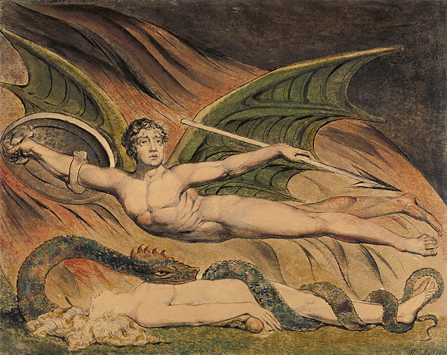 Blake also explored opposites in his works of visual art. On the right is a reproduction of one of his drawings.
- What do you notice about the figures’ poses and facial expressions?
- Based on these details, what can you deduce about what is happening?
- What are the figures holding? What do the objects symbolize?
- What do you see that are opposites?
- How would you describe the mood of this watercolor?
- What did the artist do to evoke this mood?
- Based on what you see, what do you think happened before the scene depicted in the drawing?
- What do you think will happen next?
- Why do you think the story of Adam and Eve resonates with modern-day viewers?
- What can visual art communicate about the theme of good vs. evil that cannot be communicated in poetry, and vice versa?
- How does William Blake use the medium of watercolor (as opposed to sculpture or drawing) to help communicate the story?
- Why does the theme of good vs. evil continue to be explored in various art forms?

In your journal write 1/2 -full page on why the theme of good vs. evil endures over time in literature and art.

Where do you see examples of good vs. evil in current events or daily life.
With a partner you will write original poems that explore the theme of good vs. evil in a modern-day setting.
With your partner:

- Select one topic to write about.
- Brainstorm a list of characters that would be affected by the topic.
- Blake believed that imagination is essential to life and that both poetry and visual art stem from poetic imagination. Use your imagination and write from the perspective of two different characters—one you consider “good,” and the other you consider “evil.”
- Uuse vivid imagery and include at least ONE example of allusion AND antithesis in your poem.

Reflection
- What did you learn from exploring two different perspectives of a topic?
- How realistic is it to categorize situations and people as good vs. evil?
- Revisit the journal you wrote about experiencing or witnessing good vs. evil. Would you still describe it as good vs. evil?

5  10  15  20 | A Poison Tree  by William Blake  I was angry with my friend;  I told my wrath, my wrath did end.  I was angry with my foe:  I told it not, my wrath did grow.  And I waterd it in fears,  Night & morning with my tears:  And I sunned it with smiles,  And with soft deceitful wiles.  And it grew both day and night,  Till it bore an apple bright.  And my foe beheld it shine,  And he knew that it was mine.  And into my garden stole.  When the night had veiled the pole;  In the morning glad I see,  My foe outstretchd beneath the tree. | Alliteration  Allusion  Antithesis  Apostrophe  Assonance  Consonance  Euphemism  Hyperbole  Imagery Metaphor  Onomatopoeia  Oxymoron  Personification  Simile  Symbol  Metaphor

Anger eradicates the logical aspect of life

William Blake in “The Poison Tree” starts off his poem with a conflict. A struggle between him and his friend which is solved because of their ability to discuss the problem together. The second half of the poem is about the speaker being upset with a foe who extremely rages him. The problem cannot be solved because they are enemies and communication would not be possible, so they leave the problem alone to grow. In the first half of the second stanza it is elegantly stated by the speaker that the grown enmity between them is putting so much pressure on him. Readers can tell how upset the speaker is due to the fact that he cries because of his anger. His anger is compounded even further due to the fact that he is hiding behind a false smile. It is tiring for the speaker. After days and nights of watering the wrath, it produces something. The product is symbolically an apple. The tree symbolizes the bad anger management speaker has and the apple is the result of it. Even though the apple is result of anger which is harmful, the speaker labels the apple as a benefit in his enemy’s eyes. The speaker is not painting the apple as a bad thing. A while after, the enemy that was up to no good stole the apple from speaker’s garden. The word stole signifies a corrupt action. The enemy consumes the poisoned apple and it leads to his demise. As a conclusion, if people do not manage their anger and leave it alone to grow stronger, it will make us to think irrationally and make wrong decisions. As it is symbolized in the story, the apple which is the cause to the enemy’s death is produced by the tree which symbolizes the grown anger.

